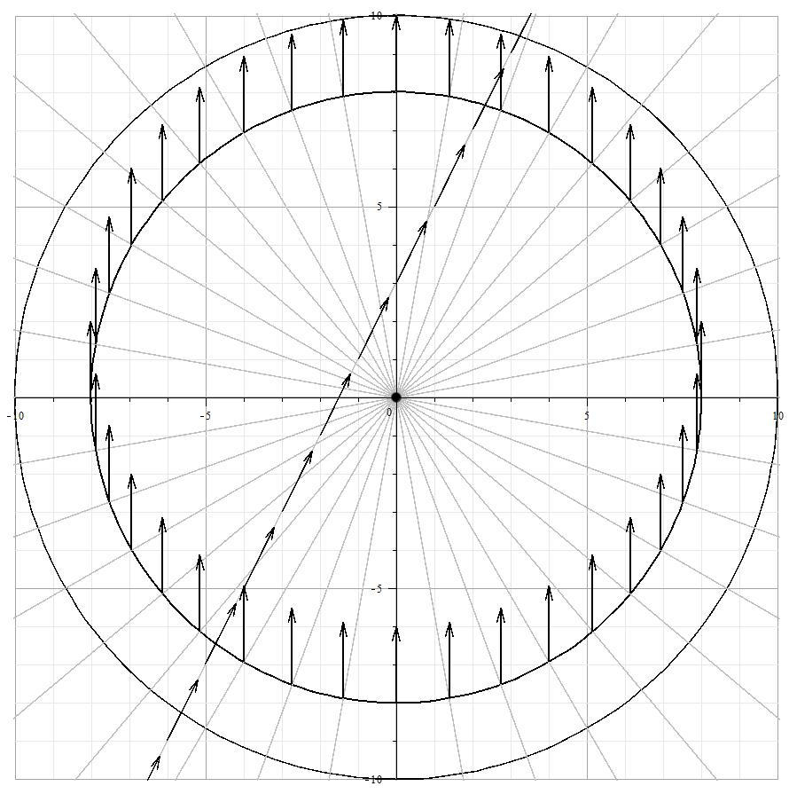

dr bob show and tell prop
www.drbobenterprises.com
Malvern Prep
November 4, 2013

